**Project Design Phase**

**Solution Architecture**

|  |  |
| --- | --- |
| Date | 10 February 2025 |
| Team ID | PNT2025TMID06968 |
| Project Name | **Predicting Plant Growth Stages with**  **Environmental and Management Data with Power BI** |
| Maximum Marks | 4 Marks |

**Solution Architecture:**

Solution architecture defines the **end-to-end technical implementation** of the project, ensuring seamless integration between **data sources, processing, analytics, and user interaction**. This architecture helps in **analyzing environmental and management data** to predict **plant growth stages**, allowing farmers and agritech companies to optimize crop yield and sustainability.

**Example - Solution Architecture Diagram:**

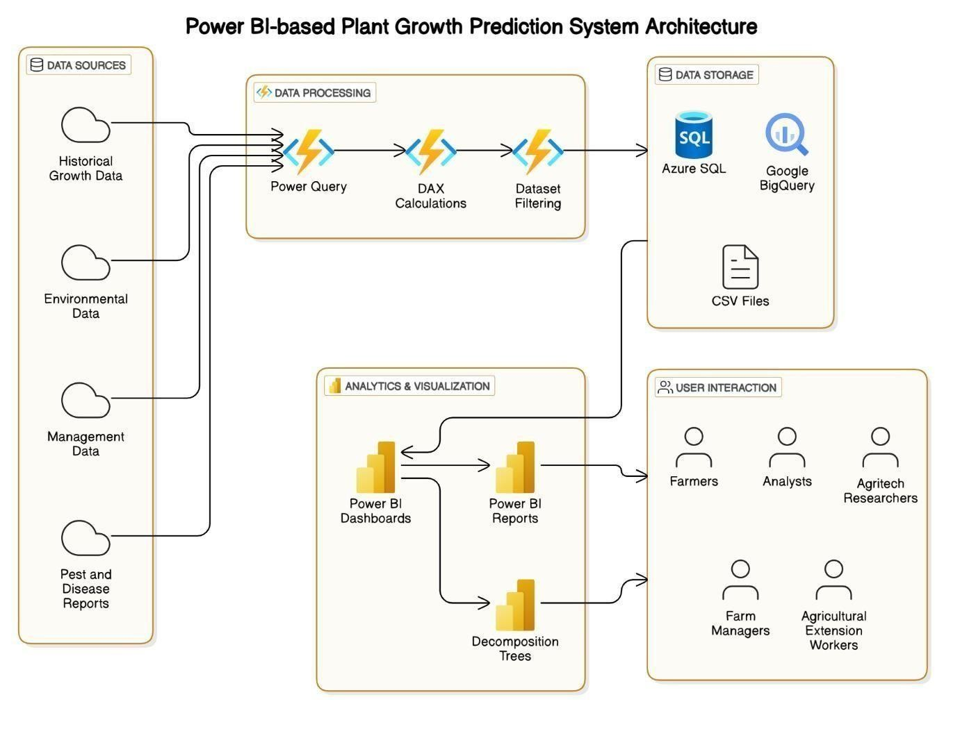

*Figure 1: Architecture and data flow of the voice patient diary sample application*